1. Provide a plot of your distance vs. launch angle experimental data* and your fit from *HW7_projectile.m*. The resulting velocity should be displayed on your graph, or if it is not, include a screen shot of the velocity displayed to the Command Window.

(*the data you used to obtain the experimental velocity you used for the competition (if applicable) or your best data)

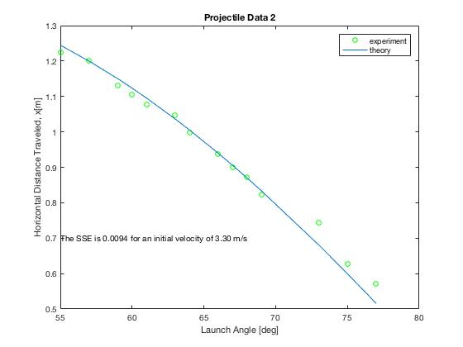

1. Provide a plot of your launch angle vs. servo angle experimental data* and your fit from *HW7_linkage.m*. The resulting offset values should be displayed on your graph, or if they are not, include a screen shot of the offset values displayed to the command window.

(*the data you used to obtain the offsets you used for the competition (if applicable) or your best data)

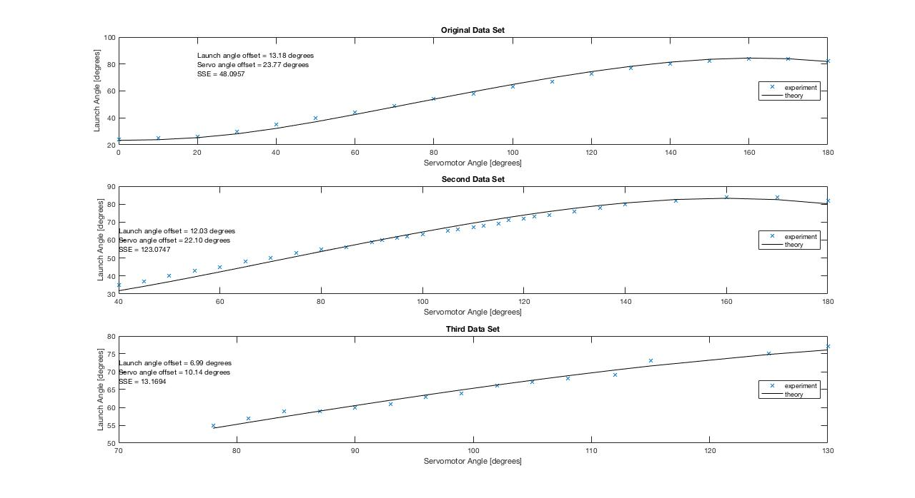

1. Were you able to hit targets using your velocity from *HW7_projectile.m* and your offsets from *HW7_linkage.m*? If not, what adjustments did you make to these or other values in order to hit targets? Were you able to use a single velocity/power for all of the targets, or did you need to split the target plate and use two different values? If you did not use the projectile motion and/or fourbar kinematics equations in your competition code, briefly describe how you accomplished your targeting.

We were not able to hit our targets using the velocity and linkage data from the homework. Although we took data multiple times and got the same result for velocity and tried the different offsets we got, none of the data combinations worked to accurately hit targets. As a result, we decided to use an empirical function. We took new sets of data for finding distances corresponding to launch angles and launch angles corresponding to servo angles. Using Matlab’s polyfit function, we generated two third degree polynomials to match the data sets. We simply used these polynomials instead of the curves given by the projectile motion and fourbar kinematics in order to calculate our servo angles to hit certain targets. This worked significantly better than before and now any miss is due to the occasional misfire of the cannon, and our cannon is far more accurate.

1. Briefly describe any ways (if any) in which you deviated from the suggested Arduino pseudocode and/or any unique programming strategies that gave you an edge in the competition.

We deviated from the Arduino pseudo code only in changing our targeting functions by using the empirical function instead of the projectile motion. We believe that the empirical function will give us an edge at the competition as it allows us to hit all range of targets much more accurately.

1. Briefly describe any ways (if any) in which you modified the hardware, actuators, or sensors in order to compete successfully.

We changed our linkage set up according to the results from the extra credit linkage assignment. Our new L values are: 131.3, 31.5, 112 and 128. As a result we had to change our reloader because the new linkage forces the canon to be higher up even at a servo angle of 0. We moved our reloader back on the set up by taking off the front bottom plate and now we attach it by screwing its front directly into the plate provided.

1. Please complete the following table:

|  |  |
| --- | --- |
|  | **Maximum # of targets hit in a single run** |
| **During the competition** | 6 |
| **During Demo 4** | 6 |
| **Ever** | 6 |

1. Briefly describe the biggest obstacle, in your opinion, to hitting targets.

The biggest obstacle to hitting targets was the fact that our cannon was very imprecise and that the projectile and fourbar code did not yield results that allowed us to hit the targets. We fixed the imprecision of the cannon by modifying the link lengths, which made it so that a slight error in servo angle would not result in as big of a difference in the launch angle. In order to have a code that yielded results allowing us to hit targets we used empirical functions instead of projectile motion and fourbar kinematics. We also ran into some problems with switches and recently had to change the pins of one of our switches because it was incorrectly reading 0 constantly, forcing the cannon to react erratically.

1. Briefly describe the most difficult aspect of the project.

The most difficult aspect of the project was hitting targets. We encountered many obstacles in attempting to hit the targets accurately, and had to take data many times before finally deciding on using an empirical function. When trying to hit targets, many things could go wrong from the code to problems in the servomotor to incorrect servo to launch angles. Optimizing the linkage and switching to using empirical functions fixed these problems.

1. Please provide any feedback you think would help us improve the project and competition in future semesters.

In the future the competition could be more interesting if more individual group freedom was allowed. It might be cooler to allow teams the option of designing and building their own cannon structures that would still fit the competition stage. This would give groups the option of possibly making more efficient cannons as well as adapting code to go along with it. Additionally, it would be cool to allow more freedom of code, such as presenting the option of using projectile or empirical functions earlier in the class, that way students had to decide which one was best for themselves. More individuality would make competition day more interesting as different groups could have different cannons and code instead of everybody having the same cannon and very similar code. It would allow for teams to put in more work in order to gain a better advantage during the competition, which in turn would make the completion more interesting.